**Empyreal Healthcare**

**IIPL**

Setup steps for

HINAI Application

**Imtac LLC**

PO Box 196, PC 116, Mina-al-Fahal,

Muscat, Sultanate of Oman



Contents

Contents

1 Install pre-requisites

1.1 TortoiseSVN

1.2 Eclipse

1.3 Tomcat 7

1.4 Maven 3

1.5 Java 1.8

1.6 WinZip   
1.7 Oracle 18c   
1.8 PostgreSQL9.5

2 SVN

2.1 Create new user credentials

2.2 Check-out source code

2.2.1 Create directory on laptop into which code will be checked-out

2.2.2 Right-click in directory and choose option SVN Checkout

2.2.3 Paste the SVN repository URL in the URL of repository field

2.2.4 Paste user credentials into pop-up

2.2.5 With till check-out process completes

3 Set up PostgreSQL.

3.1 Setting Up User Roles, Database Creation, and Role Assignment

4 Solr setup   
 4.1 File Configuration for Local PostgreSQL

5 Oracle setup   
 5.1 Installation

5.2 Install SQL Oracle Developer as GUI tool for Oracle

**6** **Setup Tomcat Server**

6.1 Modify XML configuration   
7 Deploy it on the Tomcat server

7.1 Build code

7.2 Deploy to server

# 1. Install pre-requisites

The installers are available in the “installers” folder in this shared folder.

Hello world.

<https://imtac-my.sharepoint.com/:f:/p/vinayakp/EuIzNo_PHAtJvM084iScfhwBSgWigg9GifNUiyz6UIDYDA?e=gz5PeM>

## TortoiseSVN

Run the TortoiseSVN setup file in the “installers” directory.

## Eclipse

Run the eclipse-inst-jre-win64 setup file in the “installers” directory.

## Tomcat 7

Extract and copy to a local directory.

## Maven 3

Extract and copy to local directory.

Create system variable called M2_HOME, for the maven folder.

Add the path to the maven “bin” folder, to the PATH system variable.

## Java 1.8

Run the jdk-8u381-windows-x64 setup file in the “installers” directory.

Create system variable called JAVA_HOME, for the JDK folder. In will be in the “Program Files > Java” directory.

Add the path to the JDK “bin” folder, to the PATH system variable.

## WinZip

To extract Files.

**Oracle**Installation Url: https://www.oracle.com/database/technologies/xe18c-downloads.html

# 2. SVN

## Create new user credentials

## Check-out source code

### Create directory on laptop into which code will be checked-out

### Right-click in directory and choose option SVN Checkout

### Paste the SVN repository URL in the URL of repository field

### Paste user credentials into pop-up

### With till check-out process completes

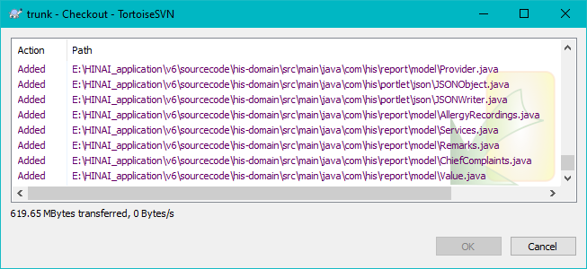

# 3.Set up PostgreSQL

## Open PgAdmin Setting Up User Roles, Database Creation, and Role Assignment

1. Create LoginRole and set username, password. Create DB and assign role to the db.

**4. Solr Setup in Local**

1. Extract solr from zip folder.
2. Go to ->D:\solr-4.10.2_brl\server\solr\patientsearch\ data-config.xml

Change db username and password:

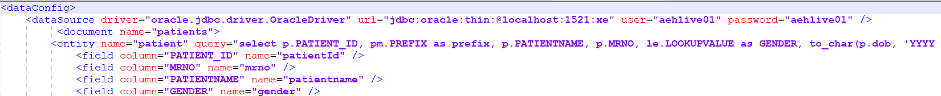

1. Go to -> D:\solr-4.10.2_brl\server\solr\patientsearch\conf\ solrconfig.xml

1. In Tomcat folder -> Go to -> D:\apache-tomcat-7.0.109\conf\server.xml  
   A screenshot of a computer

   Description automatically generated
2. Open cmd prompt -> Go to installation directory -> server folder ->

java -jar start.jar

6. Open browser - http://localhost:8983/solr/

# 5. Oracle Setup in local

**Oracle Installation Steps for Local Setup:**

1. Download Oracle from the URL provided: <https://www.oracle.com/database/technologies/xe18c-downloads.html>
2. After downloading, navigate to the installation folder and double-click on the setup.exe file located in the Oracle installation folder.



1. Proceed by clicking "Next."

1. Continue by clicking "Next."

1. Enter the desired database password.A screenshot of a computer login box

   Description automatically generated
2. Click "Install" to initiate the installation process on the local system.

1. During installation, the screen will display the following message:

**Install SQL Oracle Developer as GUI tool for Oracle.**

1. To install Oracle SQL Developer, visit the following URL: <https://www.oracle.com/database/sqldeveloper/technologies/download/>
2. Once downloaded, navigate to the folder, and double-click on sqldeveloper.exe to launch the application.  
   A screenshot of a software

   Description automatically generated

# 6 Setup Tomcat Server

1. Edit the specified file to include the paths for PostgreSQL and pgAdmin, both running locally. Additionally, include the URL path for the application.

2. Set the path where tomcat have installed.



3. Edit Tomcat -> bin -> setenv.bat file as mentioned below.



# 7. Deploy code

## Build code

## Open project in command prompt. Build code using below comman.

1. mvn eclipse:clean -Dmaven.test.skip=true -Drevision=6.2.0 - DbuildTarget=complete -Dcomplete

2.mvn eclipse:eclipse -Dmaven.test.skip=true -Drevision=6.2.0 -DbuildTarget=complete -Dcomplete

3.mvn clean -Dmaven.test.skip=true -Drevision=6.1.0 -DbuildTarget=complete -Dcomplete

4.mvn clean install -Dmaven.test.skip=true -Drevision=6.2.0 -DbuildTarget=complete -Dcomplete

## Deploy to Tomcat server

1. Once the build is completed, it will generate a WAR file. Take this file and deploy it in the Tomcat 'webapps' folder.